A000- Eur-Crete-Knossos Palace-Minoan Snake Goddess-Cobras and Lion Cub-1600 BCE

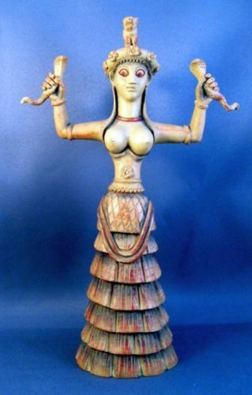

Eur-Crete-Knossos Palace-Minoan Snake Goddess-Cobras and Lion Cub-1600 BCE

**Case no.: 4**

**Accession Number:**

**Formal Label:** Eur-Crete-Knossos Palace-Minoan Snake Goddess-Cobras and Lion Cub-1600 BCE

**Display Description:**

Cretan Minoan Snake Goddess of Knossos Statue Her staring gaze denotes an oracular role of this Goddess who appears to be in a trance with her snake companions. She depicts the power of the life force, holding high the two cobras metaphorically associated with immortality, as they periodically have to shed their skins in a metaphoric death to re-emerge in a new life. Crouching on her crown is a lion cub, usually associated with royal houses. This figurine represents an agricultural fertility Goddess or her Priestess. The original was found in a storage room in the Palace of Knossos, Crete. She is a votive offering and not a cult figure and therefore, probably represents a Priestess who is perhaps a princess of the palace. Around her crown are poppy flowers signifying the use of opium as a hallucinogenic in rituals. Although she is dressed in the garb of her deity, a Cretan Earth Mother, she is a personification of Earth from which all life springs and returns.

Knossos was the ceremonial and political center of the Minoan civilization and culture. The palace was abandoned at the end of the Late Bronze Age, c. 1380–1100 BCE which coincides with the raids of the “Sea Peoples” throughout the Mediterranean. This faïence figurine identified as a "Snake Goddess" was discovered in 1903 by Sir Arthur Evans in the so-called Temple Repositories on the site of the "palace" of Knossos. Most of the faïence pieces were found in the Eastern Repository. This headdress is embellished with poppies suggesting that a hallucinogenic libation accompanied the rites to this goddess.

**LC Classification** DF221.C8

**Date or Time Horizon:** 1600 BCE

**Geographical Area:** Temple Repositories on the site of the "palace" of Knossos, Crete

**Map**

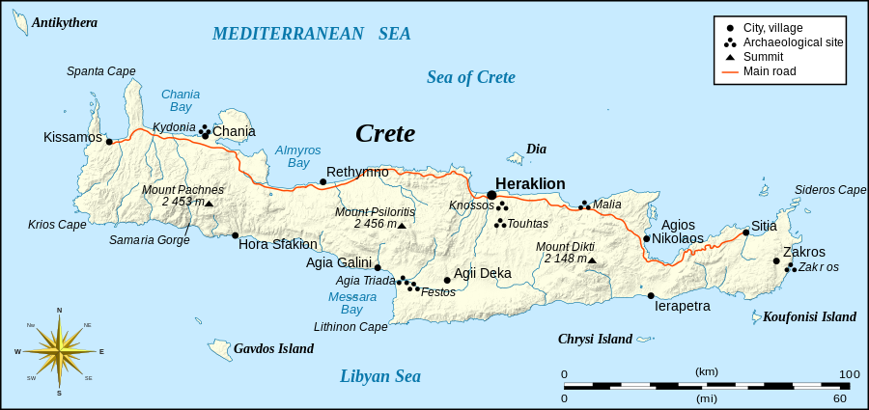

Eric Gaba ([Sting](https://commons.wikimedia.org/wiki/User:Sting)) - Own work, based on [Image:Crete_topographic_map-fr.svg](https://commons.wikimedia.org/wiki/File:Crete_topographic_map-fr.svg) (modified and translated) created by myself ; Compass rose : [Image:Brújula.svg](https://commons.wikimedia.org/wiki/File:Br%C3%BAjula.svg) (modified) created by [Serg!o](https://commons.wikimedia.org/wiki/User:Serg%21o) under GFDL

**GPS Coordinates:** 35°17'31.59" N 25°09'28.41" E

**Cultural Affiliation:** Neopalatial period, 17th century BCE 

**Geographical Area: Knossos, Crete**

**Medium:** Faience. The figurines are made of faience, a technique for glazing earthenware and other ceramic vessels by using a quartz paste. This material symbolized in old Egypt the renewal of life, therefore it was used in the funeral cult and in the sanctuaries. After firing this produces bright colors and a lustrous sheen.

**Dimensions:** 12"High (30.5 cm)

**Weight: 3 lbs, 1.4 kg**

**Condition:** replica, marble, Herakleion Museum, Crete, Greece

**Provenance:** replica, marble, Herakleion Museum, Crete, Greece

**Discussion:**

Part of one of the figurines was found in the Western Repository, which indicated to Evans that the contents of the Eastern depository had been considerably disturbed at some period, probably by plunderers at the time of the destruction of the "palace" by an earthquake around 1600 BCE. Evans implies that the faïence objects were broken at this time and most of the fragments swept into the Eastern Repository when the palace was rebuilt. Though the figurines must have been in existence before then, they are usually dated to the time of their destruction, around 1600 BCE.

They are probably (according to Burkert) related with the Paleolithic tradition regarding women and domesticity. The figurines have also been interpreted as showing a mistress of animals-type goddess and as a precursor to Athena Parthenos, who is also associated with snakes.

**References:**

Evans, Arthur. 1902-03. "The Palace of Knossos," Annual of the British School in Athens, 9:1-153.   
Evans, Arthur. 1921-1935. The Palace of Minos, 4 vols. London: Macmillan.

Gesell. Geraldine Cornelia. 1985. Town, Palace, and House Cult in Minoan Crete, Göteborg: Paul Åstroms Förlag.

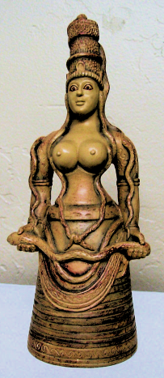**Snake Goddess Ariadne Statue  
Goddess Ariadne Statue  
9 inches high gypsumstone statue, handpainted.   
  
Antiqued stone colored gypsumstone.**

**[Candia Museum, Crete,1600-1500 BCE]**

**Antiqued stone colored gypsumstone. Here the Goddess is adorned with her Cobra and Panther headdress as she holds the snake of rebirth and regeneration.**

**Goddess of Ecstatic Trance.  
Her priestesses, bare-breasted, practiced ritual snake handling, ecstatic dancing, and prophetic trance. Priestess-queens ruled Crete, the last culture in recorded history to support equality. Her staring gaze denotes an oracular role of this Goddess who appears to be in a trance with her snake companions.**

**GREEK ARIADNE  
"The High Fruitful One," brings Rebirth**

**This lunar fertility goddess was known for her athletic prowess. Serpents, symbols of rebirth, were ritually handled by her priestesses, whose bare-breasted costumes suggest the sacred role of sexuality in the Minoan culture.**

**Serpent Goddess promotes trance and dream time. The energy exuded by the snakes of this Cretan maiden exemplify sexuality, regeneration, and the mysterious otherworld of spirit journeying. Note her staring gaze and enigmatic inward smile, and if you choose, invite these "otherworldly" characteristics into your own meditations.**

**THE DELICATE SERPENT GODDESS (of Knossos) was discovered in the underground repository of the Second Palace of Knossos (1600 BCE] and was worshiped in Crete as early as 6000 BCE. She depicts the benevolence and sacred power of the Life Force, holding high the two serpents of immortality. The tiny panther or lion cub on her headdress may connect the goddess to the fertility rites of the wine god Dionysos or denote an altered state of consciousness.**

­

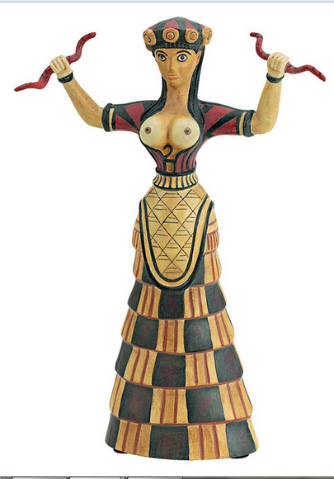Cretan Minoan Snake Goddess of Knossos Statue Sculpture Replica Reproduction

Made of cast stone

Dimensions: 12"High (30.5 cm)

Weight: 3 lbs (1.4 k

(1.4 kg)

Item No. 5082

Herakleion Museum, Crete, Greece

Period: pre-Hellenic (2800 - 800 B.C.)

Cretan Minoan Snake Goddess of Knossos Statue Sculpture Item No. 5082 Reproduced after the original from the Herakleion Museum, Crete, Greece. 1600 B.C. This figurine represents an agricultural fertility Goddess or her Priestess. The original was found in a storage room in the Palace of Knossos, Crete. She is a votive offering and not a cult figure and therefore, probably represents a Priestess who is perhaps a princess of the palace. Although she is dressed in the garb of her deity, a Cretan Earth Mother, she is a personification of Earth from which all life springs and returns. She carries the snakes, symbols of death and rebirth. Crouching on her crown is a lion cub, usually associated with royal houses. In her crown are poppy pods, indicating the use of opium in her worship.

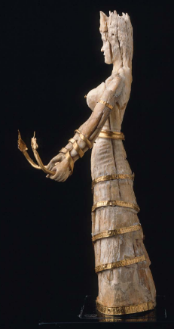 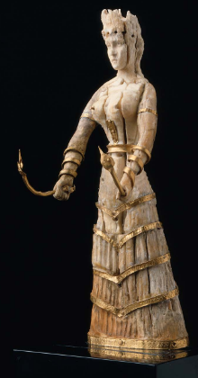 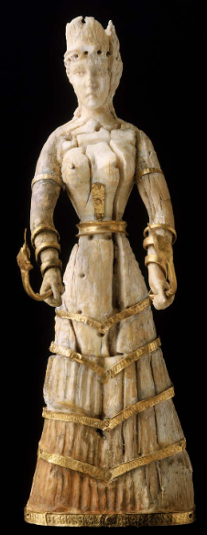

Snake goddess ivory statuette, Minoan Bronze Age, 1600-1500 BCE

**Formal Label:** Snake goddess ivory statuette, Minoan Bronze Age, 1600-1500 BCE

**Accession Number:** NB91.P25

**Date or Time Horizon:** Minoan Bronze Age, 1600-1500 BCE

**Geographical Area:** Knossos, Crete

**Cultural Affiliation:** Minoan Bronze Age, 1600-1500 BCE

**Medium:** Gold, ivory

**Dimensions:** 16.1 cm (6 5/16 in.)

**Weight:**

**Provenance:** BMFA, 14.863

**Condition: Museum**

**Discussion:**

The elaborate headdress, or crown,

is of a type which appears to be without parallels in Minoan art.

It curves up at the front, back, and sides in semi-circular form,

and a small cyhndrical piece,

now much damaged, rises in

the centre. Each of the four

semi-circular divisions is

pierced near the top for the

attachment of a rosette or

some other ornament, prob-

ably of gold, and the one at

the front is further decorated

with a small raised disk, or

boss. A gold band encircled

the crown near the bottom, as

is proved by a nail hole at the

back. The hair over the forehead is treated as a slightly raised

mass in which is a row of seven drilled holes, about 6 mm. deep,

with shallow circular depressions between them. On the analogy

of the well known ivory heads from Knossos (Fig. 1, reproduced

from B.SA, VIII, p. 72, figs. 37, 38), it may be confidently as-

serted that these holes held small gold curls, and that they did not

serve for the attachment of a gold wreath, or diadem, as Gard-

ner has suggested. Numerous frescoes show that such loose

tendrils of hair floating about the forehead were a characteristic

**References:**

Caskey, Lacey Davis. 1915. [**A Chryselephantine statuette of the Cretan snake-goddess in the Museum of Fine Arts, Boston**](http://www.worldcat.org/title/chryselephantine-statuette-of-the-cretan-snake-goddess-in-the-museum-of-fine-arts-boston/oclc/83217450&referer=brief_results) . Museum of Fine Arts, a reprint of the article in the American Journal of Archaeology, 1914.